Project Design Phase-II
Data Flow Diagram & User Stories

Date | 08 August 2026
Name | Shilpa Pachumbre
Project Name | House Rent MERN
Maximum Marks | 4 Marks

Data Flow Diagrams:
A Data Flow Diagram (DFD) is a traditional visual representation of the information flows within a system. A neat and clear DFD can depict the right amount of the system requirement graphically. It shows how data enters and leaves the system, what changes the information, and where data is stored.

Example: (Simplified)
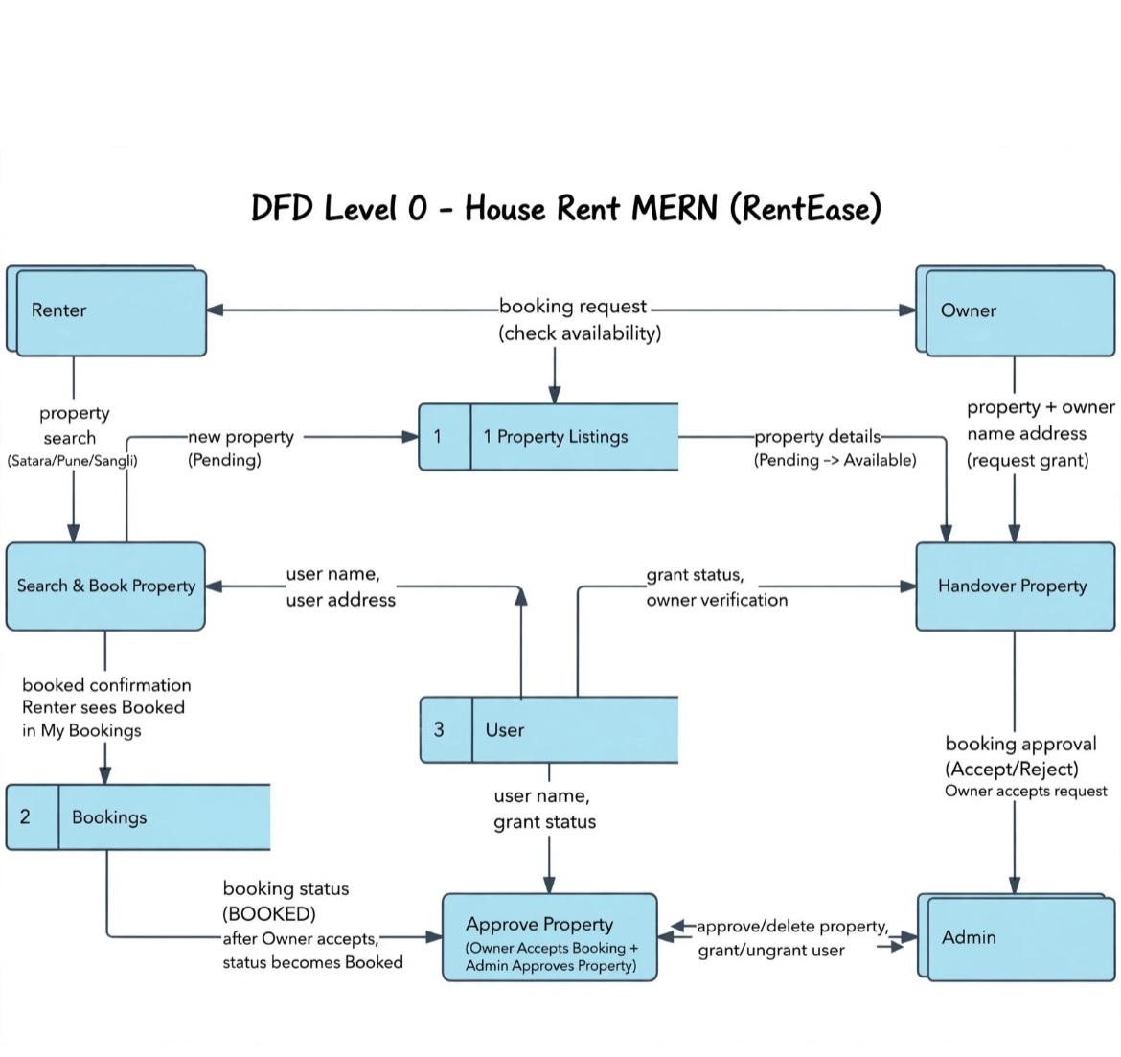
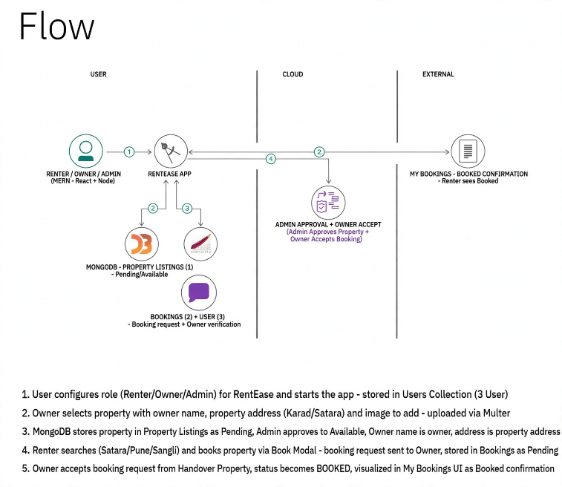

User Stories
Use the below template to list all the user stories for the product.
User Type | Functional Requirement (Epic) | User Story Number | User Story / Task | Acceptance criteria | Priority | Release
Renter | Registration | USN-1 | As Renter, I can register/login as Renter | Access Renter dashboard, see properties | High | Sprint-1
Renter | Search & Book | USN-2 | As Renter, I can search property by location & book via dates+phone | Booking request Pending goes to Owner | High | Sprint-1
Renter | My Bookings | USN-3 | As Renter, I can see BOOKED status after Owner accepts | My Bookings madhe Booked confirmation | High | Sprint-2
Owner | Registration | USN-4 | As Owner, I can register & request grant from Admin | Grant Pending till Admin grants | High | Sprint-1
Owner | Add Property | USN-5 | As Owner, I can add property with owner name, property address, rent, images | Property in 1 Listing as Pending | High | Sprint-1
Owner | Accept Booking | USN-6 | As Owner, I can view & Accept/Reject Renter booking request | After Accept, status becomes BOOKED | High | Sprint-2
Admin | Approve Property | USN-7 | As Admin, I can Approve/Delete property Pending->Available | Property visible to Renters after approve | High | Sprint-1
Admin | Grant Owner | USN-8 | As Admin, I can Grant/Ungrant Owner verification | 3 User madhe grant status update | High | Sprint-1

